
Faith Lutheran Church, ELCA
1700 E Pettit Ave
Fort Wayne, In 46806
PH: 260-745-2565
Fax: 260-456-6282

Email: faithfw@Frontier.com
On the Web: www.faithfw.com

Office Hours: Mon-Thurs from 10 am – 2 pm. Closed for lunch from 12:00-12:30 pm.

¹⁸"The Spirit of the Lord is upon me,
because he has anointed me to bring good news to the poor.
He has sent me to proclaim release to the captives
and recovery of sight to the blind, to let the oppressed go free,
¹⁹to proclaim the year of the Lord's favor." Luke 4:18-19

In Luke’s Gospel Jesus enters the temple in Nazareth, reads these words from the scroll of Isaiah, and thus declares his mission in the world. Jesus makes the purpose of his ministry clear to those around him – to bring good news, to restore, release, and renew, to proclaim God’s goodness and love. And yet, even with the clarity of his mission and purpose, many times in each of the four Gospels, Jesus takes time to retreat to a quiet place, to pray, to reflect, to seek renewal. Jesus pauses in the midst of his ministry because he needed it.
Here at Faith we find ourselves needing to do the same, to seek renewal and clarity in our mission. For more than four years I’ve served as your pastor, leading us through various phases of ministry. We’ve bid farewell to leaders and ministries. We’ve welcomed new leaders and staff, and taken on new projects. We’ve followed where God led us. But now we find ourselves, like Jesus, needing to take a moment for reflection, renewal, and further guidance. We find the need to reflect more carefully on how we are being led by God to carry on this ministry of Jesus Christ.
In March we welcomed brothers and sisters from the ELCA who walked with us through a comprehensive review of the ministry here. We spent hours in conversation and inquiry, ending with a lengthy list of affirmations and recommendations. Our time together produced much fruit, many ideas, and possible next steps. Ideas and next steps the church council and Renewal team (aka the Hot Mamas) will share with the rest of the congregation.
One of the recommended first steps began in late April as five of us participated in “Connect,” a series of four workshops held every six months through the Indiana – Kentucky Synod. These workshops and the follow up activities are designed to assist congregations like ours who are engaging in a process of renewal and reflection.
One of the most important pieces of information our team learned at this workshop is that there is NOT an easy answer to “grow a church” or “fix” a problem. There is no “5 quick steps” or simple solution to restore a congregation. And it isn’t something that can be done by one or two people, or by a pastor. Renewal, Transformation, and growth occurs in settings where the whole congregation knows the mission, supports it, and engages as actively as they can in the mission of God.
So what does this mean for Faith?

Continued on the next page …
It means we return to some basics. Prayer, Bible Study, reflection. Several of us already pray each day at 11 am. We set alarms on our phones, clocks, computers or other devices to remind us. And then we take a moment at 11 am to pray for Faith, for the people, for the ministry, for God to reveal to us what God wants us to do and be in God’s name. We pray.
We also return to time for Bible Study. Beginning June 11 our Sunday Bible Study returns after worship from 10:45-11:30 each week. Open to all ages, we will study various stories of the early church, and learn ways to continue this study in our daily lives.
Next, we take a moment for reflection. Sunday, June 4, and Wednesday, June 7, each person in worship will be invited to complete a congregational survey. This survey is part of the Connect workshop, with the purpose to in essence “take the temperature” of the congregation. It isn’t a test or a measure by which the ELCA will come in and close us down. It’s a way for us to get a sense of the health of the congregation.
Along this process of renewal we welcome several partners – Pastor Jeff Hawkins, who preached and visited with us in May. And Pastor Nancy Nyland, from the Indiana-Kentucky Synod who will visit with the church council in June. Each comes to share wisdom with us, and to bring supportive resources for us to use and implement in our ministry together. We look forward to their collaboration with us in this time.
Jesus knew his mission here on earth. Jesus was clear about his purpose. As followers of Jesus, we seek to do likewise. To identify and share our mission and purpose. To know what God has called us to be and to do in this time and place. To use the resources God has given us wisely. To serve faithfully in the name of Jesus. I thank you for your prayers, your faith, and your trust as we discern this together.
Lydia’s Closet
“Sensibly priced, upscale thrift & boutique clothing”

New Store Hours:
Tuesday ◊ 10 am – 2 pm
Wednesday ◊ 3 pm – 6 pm
Thursday ◊ 10 am – 2 pm
Friday ◊ 2 pm – 6 pm
Saturday ◊ 10 am – 1 pm
Closed ◊ Sunday & Monday

Email: LydiasClosetFW@gmail.com
Phone: 260-745-2565 (Faith Lutheran Church)

Clothing Donations
Always Welcome!
In Christ,
Pastor Marty Hampton
Weekly Bible Study

Starting Sunday June 11 weekly Bible Study will resume. Plan to stay after worship for this opportunity to dig deeper into God’s Word! We will meet in the fellowship hall! See you there!



“Music Notes”

Greetings Brothers and Sisters in Christ,

June 4th is the Festival of Pentecost! The paraments and banners that day will be red and reflective of the Holy Spirit. It is also traditional to wear red to worship on Pentecost Sunday. Remain after worship for the Pentecost Picnic, which will be held in the Fellowship Hall. If you would like to bring a dish to share, please find the sign up on the table in front of the office, there is also the opportunity to donate $ toward the cost of the chicken to be brought in or just come and enjoy the meal and the fellowship. There will be plenty of food so consider inviting friends and family to join us!
June 11th is the Festival of the Holy Trinity. Celebrate with us the Triune God!
June 18th is Father’s Day and also the beginning of what we call “Ordinary Time” but you probably remember it as “Sundays after Pentecost”. The color of the season is green to represent growth and nurture in the faith. This is the longest season in the church year and except for Reformation Sunday and All Saints Sunday, continues until Christ the King Sunday in November (which is the Sunday before Advent). This is the season when we hear the stories and parables of Jesus’ ministry. The liturgy will shift to that of hope and praise, and we will include the return of “Watch O Lord” at the conclusion of the Prayers of Intercession
As always, we are in need of Worship Assistants. If you are interested in serving as a Lay Reader, Communion Assistant and Assisting Minister, please see Pastor Marty or me.

For the Music Ministry at Faith,
Marceile Redmon
JUNE
BIRTHDAYS

3 - Deidre Dorsett
8 - Steve Kingsley
10 - Chuck Blosser
10 - Doug Brouwer
11 - Barbara Weinert
12 - Tony Figurelli
18 - Leroy Cook
24 - Matthew Hampton
24 - Helene Lilly

PENTECOST PICNIC

Sunday, June 4 we gather as a congregation for our annual picnic after worship. Fried Chicken, drinks, and dinnerware will be provided. Please sign up if you are able to bring a salad or dessert to share.

During this time, two important opportunities will take place!
- Mr. Chris Burnette from the ELCA Regional Gift Planner will be present to speak with individuals about opportunities to review their estate plans and ways to ensure their investments and other bequests will be left for the people or charities intended! He will bring a greeting during our worship time, and then be present to meet with folks following worship.
- ALL participants at Faith will be encouraged to complete a survey we are conducting as part of our ministry review process! More information was shared in Pastor Marty’s monthly article. It is crucial for each person to complete one of these! Thanks!

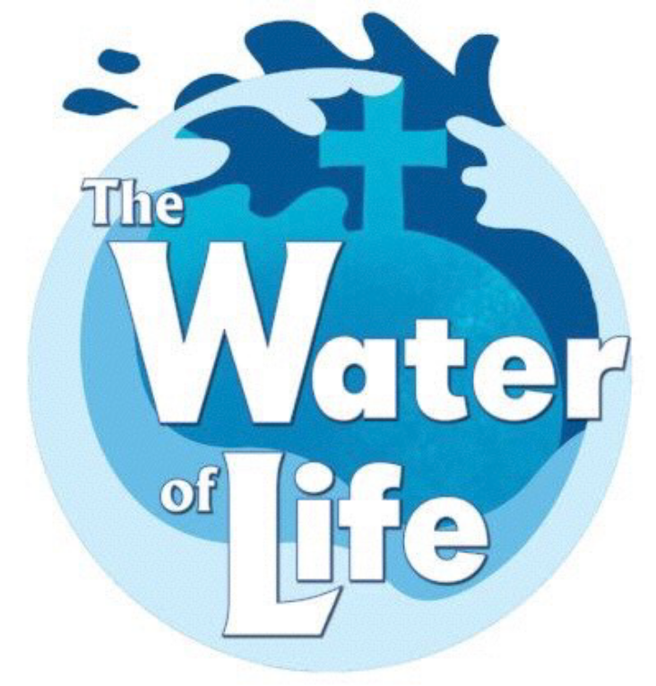

Faith is looking for donations of:

- Cereal – Frosted Flakes, Life, Honey Nut Cheerios, Lucky Charms, Chex
- Milk – 2% or Skim
- Peanut butter
- Jelly
- Bread – white and wheat
- Baby carrots
- Apples
- Bananas
- Chips
- Packages of cookies
- Granola bars
Vacation Bible School

Faith is now accepting registrations for all children in grades Kindergarten through Middle School for Vacation Bible School. Each day will include time for Bible Study, songs, games, and crafts. Breakfast, lunch, and two snacks will be provided free to all participants.

WHAT: Vacation Bible School
WHERE: Faith Lutheran Church
1700 E. Pettit Ave.
Fort Wayne, IN
WHEN: June 26-29 9:00 am - 3:30 pm
Friday, June 30 9:00-1:00
* Breakfast at 8:30 am
WHO: For children entering grade 1-6

Breakfast, Lunch & Snacks will be provided.

Register now at the church office by calling
260-745-2565 or go to www.eventbrite.com/e/faithlutheran-churchcommunity-vbstickets-34284723531
Housing needed!

Faith is again asking folks to consider hosting one or more of our Lutheran Outdoor Ministry Staff at their home during the week of VBS.

What you will need to provide:

- a separate room with a bed.
No couches please!
- Supper on three of the evenings.
If you are able to host a staff person,
please let Pastor Marty know! Thanks!
Sharing Our Knowledge

Often we think that we do not know enough to be able to reach others. We might even become hesitant to tell others what we know, out of fear that we won’t have anything left to say when we are asked for more.
This mind set makes us anxious, secretive, possessive and self-conscious. But when we have the courage to share generously with others all that we know whenever they as for it, we soon discover that we know a lot more than we thought. It is only by giving generously from the well of our knowledge that we discover how deep that well is.

~ Henri Nouwen

Text excerpts taken from Bread for the Journey, by Henri J.M. Nouwen, copyright 1997 Harper SanFrancisco. All scripture from The Jerusalem Bible copyright 1966, 1967 and 1968 Darton, Longman and Todd and Doubleday and Co. Inc. All rights reserved.

UGANDAN CHILDREN’S CHOIR

Mark your calendars for Sunday, July 9th at 6pm. The Ugandan Children’s Choir will be performing a concert at Broadway Christian Church (910 Broadway, Fort Wayne). Visit their website for more information www.childcareworldwide.org

According to their website: “The children in the Ugandan Kids Choir bring a message of hope—sharing the power of God’s love through traditional music and dance. As they tour the US, they delight audiences with their high-energy performances and infectious joy. Each choir is made up of 10 sponsored children who come from the poorest parts of Uganda. The children are chosen for their enthusiasm, ability, and dedication—all of which make them potential leaders when they return to their communities. They are eager to perform for you, and provide you an opportunity to help poor children around the world, put an end to poverty, hunger and corruption”

(Founded in 1981, Childcare Worldwide is a Christian child sponsorship ministry dedicated to sharing the gospel, providing hope, and developing the unlimited potential of impoverished children around the world.)
LAZARUS CHICKEN SALAD RECIPE
4 Cup cooked chicken cubes 16 oz. Miracle Whip
1/2 lb diced dates 1 tsp sugar
1 Cup diced pineapple – drained 1/4 Cup canned milk
1 Cup diced celery 2 T lemon juice
1/4 Cup slivered almonds Juice from pineapple -- as needed
Mix chicken, dates, pineapple, celery and almonds. In separate bowl mix remaining dressing ingredients. Toss together and refrigerate. Can be served with crackers, baked in crescent rolls for parties.
This recipe came from the restaurant at Lazarus department store in downtown Columbus, Ohio. It was the featured specialty on the lunch menu.

Family Fun Night Meal
VOLUNTEERS

June 7
Vivian, Jane, Karen

June 14
Gina Grant, Janet Frede, Jessica

June 21
Grace

June 28
Dorothy, Jan Smith

July 5
Vivian, Jane, Karen
Desserts – Vivian, Jane

July 12
Janet Frede, Gina Grant
Desserts – Jean Kinsey

July 19
Grace

July 26
Dorothy, Jan Smith
Desserts – Dorothy, Jan

LIGHT OF THE CROSS FOOD BANK
PANTRY REPORT

Reporting April 2017 Activity

In April, the LOTC Pantry provided meals for 739 individuals residing in 186 households, down some from the previous month. Those served included 94 children 5 years of age or under, 227 children ages 6 thru 17, 86 individuals 60 years old or older, 102 disabled people, and 10 veterans including 2 women. Of the client households served, 92 were "Female Head of Household."

Food sources in April included 1,168 pounds from TEFAP (the federal government's commodities program), 1,000 pounds from the Associated Churches Food Bank Network, and 289 pounds from the partner churches. An additional 1,513 pounds of food was purchased from the Community Harvest Food Bank Network at a cost of $304.81. The 22 volunteers who served in April donated 204 hours of their time in service to the LOTC Pantry.

Also in April, the pantry distributed Easter hams and dessert mixes to 189 client households. The Pantry thanks the Alpha Kappa Sorority for their donations of both money and food to LOTC in April.

The Sharing Grace Contribution mailing labels have been distributed. If you have not received yours please speak with your congregation's representative.

In June and December, the Pantry requests non-food items be donated. Below is a list of typical items needed.

Thank you, one and all, for your continued support of this ministry. You are appreciated.

PARTNER ASSIGNMENTS FOR JUNE

Items of a non-food nature, including:
Laundry Soap, Dish Liquid, Cleaning Products,
Bar Soap, Shampoo, Toothpaste, Deodorant, Feminine Hygiene Products, Toiletries for Men and Women, Bathroom Tissue, Paper Products,
and items of a similar nature.

June Food items: Canned Fruit & Soda Crackers

 | June 2017
Sun | Mon | Tue | Wed | Thu | Fri | Sat
 |  |  |  | 1  1 pm – Good Neighbors | 2 | 3  12:30 -2:30 pm  Narcotics Anonymous
4  9:30 am  Worship  Pentecost Picnic  (Formerly “No Ants”)  12 pm  ABC Ministries |   5  Summer Lunch Program  June 5 – July 28 | 6  9 am - Sew–Sew | 7  FAMILY FUN NIGHT  5:30 pm Activities & Crafts  6 pm Prayer & Praise  6:30 Free Community Meal | 8 | 9 | 10  12:30 -2:30 pm  Narcotics Anonymous
11  9:30 am  Worship  12 pm  ABC Ministries | 12 | 13  9 am - Sew–Sew | 14  FAMILY FUN NIGHT  5:30 pm Activities & Crafts  6 pm Prayer & Praise  6:30 Free Community Meal | 15 | 16 | 17  12:30 -2:30 pm  Narcotics Anonymous  1 pm  Men to Young Men
18  9:30 am  Worship  12 pm  ABC Ministries | 19 | 20  9 am - Sew–Sew | 21  FAMILY FUN NIGHT  5:30 pm Activities & Crafts  6 pm Prayer & Praise  6:30 Free Community Meal | 22 | 23 | 24  12:30 -2:30 pm  Narcotics Anonymous
25  9:30 am  Worship  12 pm  ABC Ministries  4 pm  Vacation Bible School June 26th – June 30th 9am - 3:30pm (Breakfast @ 8:30am)  VBS Kick Off | 26  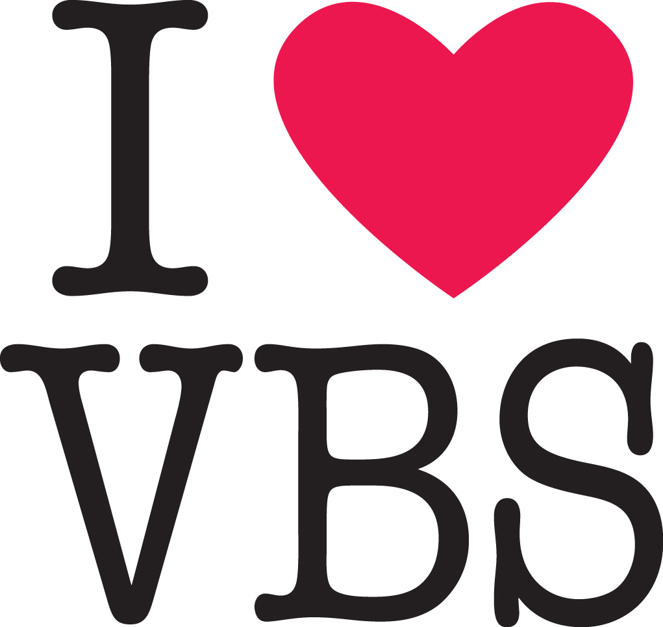 | 27  9 am - Sew–Sew | 28  FAMILY FUN NIGHT  5:30 pm Activities & Crafts  6 pm Prayer & Praise  6:30 Free Community Meal | 29 | 30

